NEPAL COLLEGE OF INFORMATION TECHNOLOGY
Balkumari, Lalitpur
Affiliated to Pokhara University

LAB REPORT FOR SIMULATION AND MODELING


LAB REPORT 2: MONTE CARLO METHOD AND COBWEB MODEL

Submitted by: Submitted to:
Name: Arpan Adhikari Resha Deo
Roll No.: 231309
BECE (6th SEM)

THEORY:

Monte Carlo Method
The Monte Carlo Method is a computational technique that uses random sampling and probability to solve mathematical and engineering problems. It is particularly useful when analytical solutions are difficult or impossible to obtain. The method relies on generating a large number of random inputs and observing the outcomes to estimate numerical results.
The basic principle of the Monte Carlo Method is that as the number of random samples increases, the estimated result approaches the actual value. It is widely used in areas such as numerical integration, optimization, risk analysis, artificial intelligence, physics, finance, and computer simulations.

Steps of Monte Carlo Method:
- Define the problem and its possible outcomes.
- Generate random input values within the specified range.
- Perform simulations using the generated values.
- Record the results of each simulation.
- Analyze the results and estimate the final solution.

Mathematical Equation:

We generate N random samples​ uniformly distributed in [a,b]. The Monte Carlo approximation is:

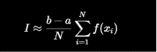

Cobweb Model
The Cobweb Model is an economic model that explains fluctuations in prices and quantities in markets where there is a time lag between production decisions and actual supply. It is commonly used to study agricultural markets where producers decide the quantity to produce based on current prices, but the goods reach the market later.
According to the Cobweb Model, producers adjust their production levels based on previous market prices. If the price is high, producers increase production, leading to excess supply and lower prices in the next period. Conversely, if the price is low, production decreases, causing shortages and higher prices later. This continuous adjustment creates a cobweb-like pattern when plotted on a graph.

Assumptions of the Cobweb Model
- Producers base production decisions on past prices.
- There is a time lag between production and supply.
- Demand depends on the current market price.
- Producers aim to maximize profit.
- Market conditions remain relatively stable.

Mathematical Equations:
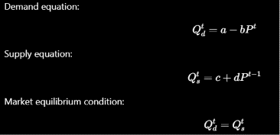

C-PROGRAMS AND OUTPUT:

Monte Carlo Method

#include <stdio.h>

#include <stdlib.h>

#include <math.h>

float f(float x)

{

return sqrt(1 - x * x);

}

int main()

{

float x, y;

int n = 0, N;

for (N = 1; N <= 100000; N++)

{

x = ((double)rand() / (RAND_MAX));

y = ((double)rand() / (RAND_MAX));

if (y <= f(x))

{

n++;

}

}

printf("n=%d \n N=%d", n, N);

float pi = 4.0 * n / N;

printf("Using monte carlo simulation value of pi = %f", pi);

float error = (3.1415-pi)/3.1415;

printf("Error = %f",error);

return 0;

}

Output:

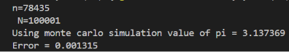

Cobweb Model

#include <stdio.h>
int main()
{
FILE *fp;
fp = fopen("data.xls", "w");
float a = 12.4, b = 1.2, c = 1.0, d = 0.9;
float p[35];
float Q[35]; //= a-bp
float S[35]; // c+dp
float initial_price = 1.0;
// p[0] = 1.0;
fprintf(fp, "Price\t Supply\t Demand\n");
for (int i = 0; i <= 34; i++)
{
S[i] = c + d * initial_price;
Q[i] = S[i];
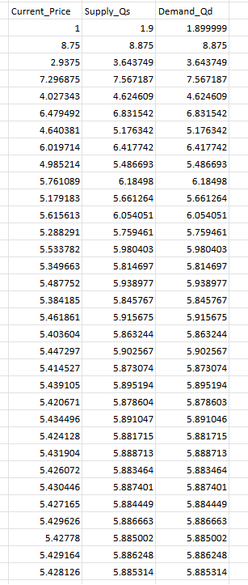
p[i] = (a - Q[i]) / b;
initial_price = p[i];
fprintf(fp, "%f\t %f\t %f\n", p[i], S[i], Q[i]);
printf("S[%d] = %f\n", i, S[i]);
printf("Q[%d] = %f\n", i, Q[i]);
printf("P[%d] = %f\n", i, p[i]);
}
fclose(fp);
return 0;
}

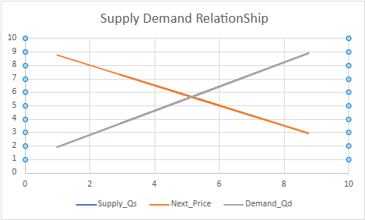

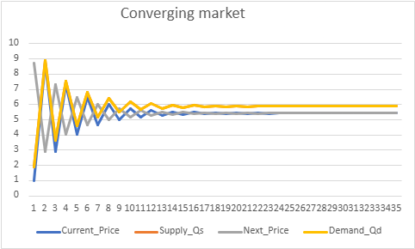

CONCLUSION:
Through this laboratory exercise, the concepts of the Monte Carlo Method and Cobweb Model were successfully studied and implemented using C programming. The Monte Carlo simulation demonstrated how random sampling can be used to estimate the value of π with reasonable accuracy, highlighting the practical application of probability in numerical computations. The Cobweb Model simulation illustrated the dynamic interaction between supply, demand, and price over time, showing how market prices adjust due to production delays. Overall, the experiment provided a better understanding of simulation techniques and their applications in solving mathematical and economic problems.

